34.64: 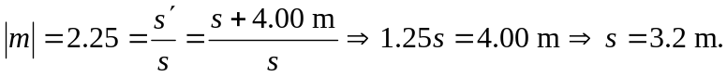 So the mirror is
7.20 m from the wall. Also:
